**ABSTRACT**

In this mini-project, we have included most of the data base management system concepts. Few of the main concepts included in this mini-project are creation of tables, insertion of values into the tuples, deletion of information and updating the values. The software package can be readily used by non-programing personal avoiding human handled chance of errors. The main aim of entire activity is to automate the process of day-by-day activities of vehicle like user activities, users, assign a bus according to demand etc. The project “Automobile Service Management System” is developed to demonstrate few basic concepts of database management system. This mini Project helps at to make most of the vehicle service management related functions automated. The complicated process of Automobile service management system is made as simple as possible using structured & menu oriented interface.

**CONTENTS**

**Chapter no. Page no.**

1. **Introduction 4**
   1. Purpose of the Project
   2. Aim of the Project
   3. Scope
   4. Proposed system
2. **System requirement specifications 6**
   1. Introduction
   2. Hardware requirements
   3. Software requirements
3. **System Design 7** 
   1. ER Diagram
   2. Schema
4. **System Implementation 9**
   1. Implementation
   2. Front End
   3. Back End
   4. Modules
   5. Implementation Code
5. **System Testing 16**
   1. Software testing
   2. Integration testing
   3. Unit testing

**7.** **Snapshots** **19**

**8. Conclusion 23**

**References**

**CHAPTER 1**

**INTRODUCTION**

**BRIEF DESCRIPTION OF PROJECT**

* 1. **PURPOSE**

The project “Automobile Service Management System” is developed to demonstrate few basic concepts of database management system. This mini Project helps at to make most of the vehicle service management related functions automated. The complicated process of Automobile service management system is made as simple as possible using structured & menu oriented interface. In this mini-project, we have included most of the database management system concepts. Few of the main concepts included in this mini-project are creation of tables, insertion of values into the tuples, deletion of information and updating the values.

* 1. **AIM OF THE PROJECT**

The software package can be readily used by non-programing personal avoiding human handled chance of errors. The main aim of entire activity is to automate the process of day-by-day activities of vehicle as user activities, users, assign a bus according to demand etc.

* 1. **SCOPE**

A computer based management system is designed to handle all the primary information required to calculate monthly statements or daily statements. Separate database is maintained to handle all the details required for the correct statement calculation and generation. This mini project intends to introduce more user friendliness in the various activities such as record update, service maintenance, save records. The report is chalked out into sections describing the basic requirements superseded by the briefing on functions used. Following this, the detailed description of how the implementation is done effectively using these functions and SQL language is presented. The source code is provided along with necessary comments to enhance readability of code.

* 1. **PROPOSED SYSTEM**

*A customer can check the current vehicle status with a customer ID & password and user can see the vehicle details and payment, status of the vehicle.

*Customer can see what and all services provided by management.

*It will save the time and increase the work speed.

*It will provide the special feature to store the customer and vehicle details.

*Along with this user can give feedback.

*Payment details & online payment is provide.

1. **Planned approach towards working: -** The working in the organization will be well planned and organized. The data will be stored properly in data stores, which will help in retrieval of information as well as its storage.

2. **Accuracy: -** The level of accuracy in the proposed system will be higher. All operation would be done correctly and it ensures that whatever information is coming from the center is accurate.

3. **Reliability:** - The reliability of the proposed system will be high due to the above stated reasons. The reason for the increased reliability of the system is that now there would be proper storage of information.

5. **Immediate retrieval of information: -** The main objective of proposed system is to provide for a quick and efficient retrieval of information. Any type of information would be available whenever the user requires.

6. **Immediate storage of information: -** In manual system there are many

Problems to store the largest amount of information.

7. **Easy to Operate: -** The system should be easy to operate and should be such that it can be developed within a short period and fit in the limited budget of the user.

**CHAPTER 2**

**SYSTEM REQUIREMENT SPECIFICATIONS**

**2.1 INTRODUCTION**

**2.2 HARDWARE REQUIREMENTS**

Processor: Intel i5

RAM: 8.00 GB RAM Hard Disk Space: 500 GB

Keyboard: Standard Windows Keyboard

**2.3 SOFTWARE REQUIREMENTS**

Operating System: Windows 10

Front End: HTML, PHP, CSS, JavaScript, Bootstrap, Ajax

Text Editor: Notepad++

Back End: MySQL

## 2.4 FUNCTIONAL REQUIREMENTS

The functional requirements Specification documents the operation and activities that a sys- tem must be able to perform.

* Keeping records of different vehicles.
* Keeping record of feedback form.
* Validating the status of the customer record.

## 2.5 NON- FUNCTIONAL REQUIREMENTS

* Secure access.
* 24*7 availability.
* Better component design to get better performance at peak time.

**CHAPTER 3**

**SYSTEM DESIGN**

**3.1 CONCEPTUAL DESIGN**

**3.1.1 ER DIAGRAM**

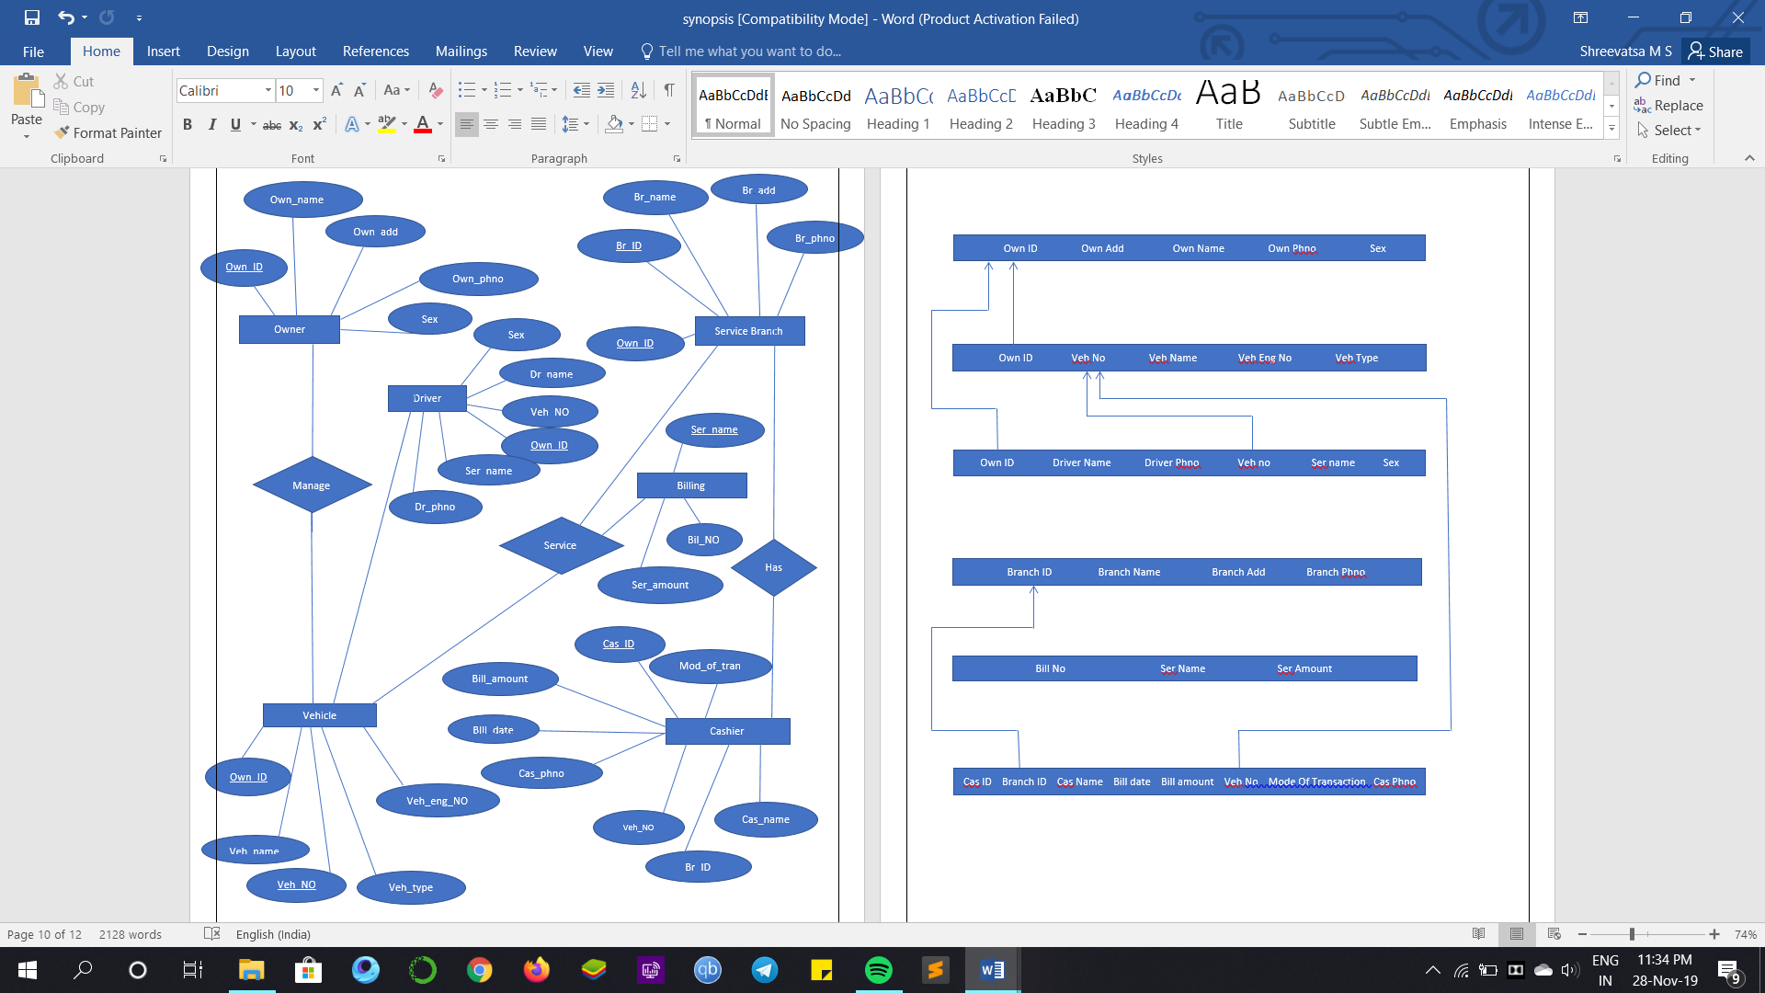

Figure 3.1:ER Diagram

**3.1.2SCHEME DIAGRAM**

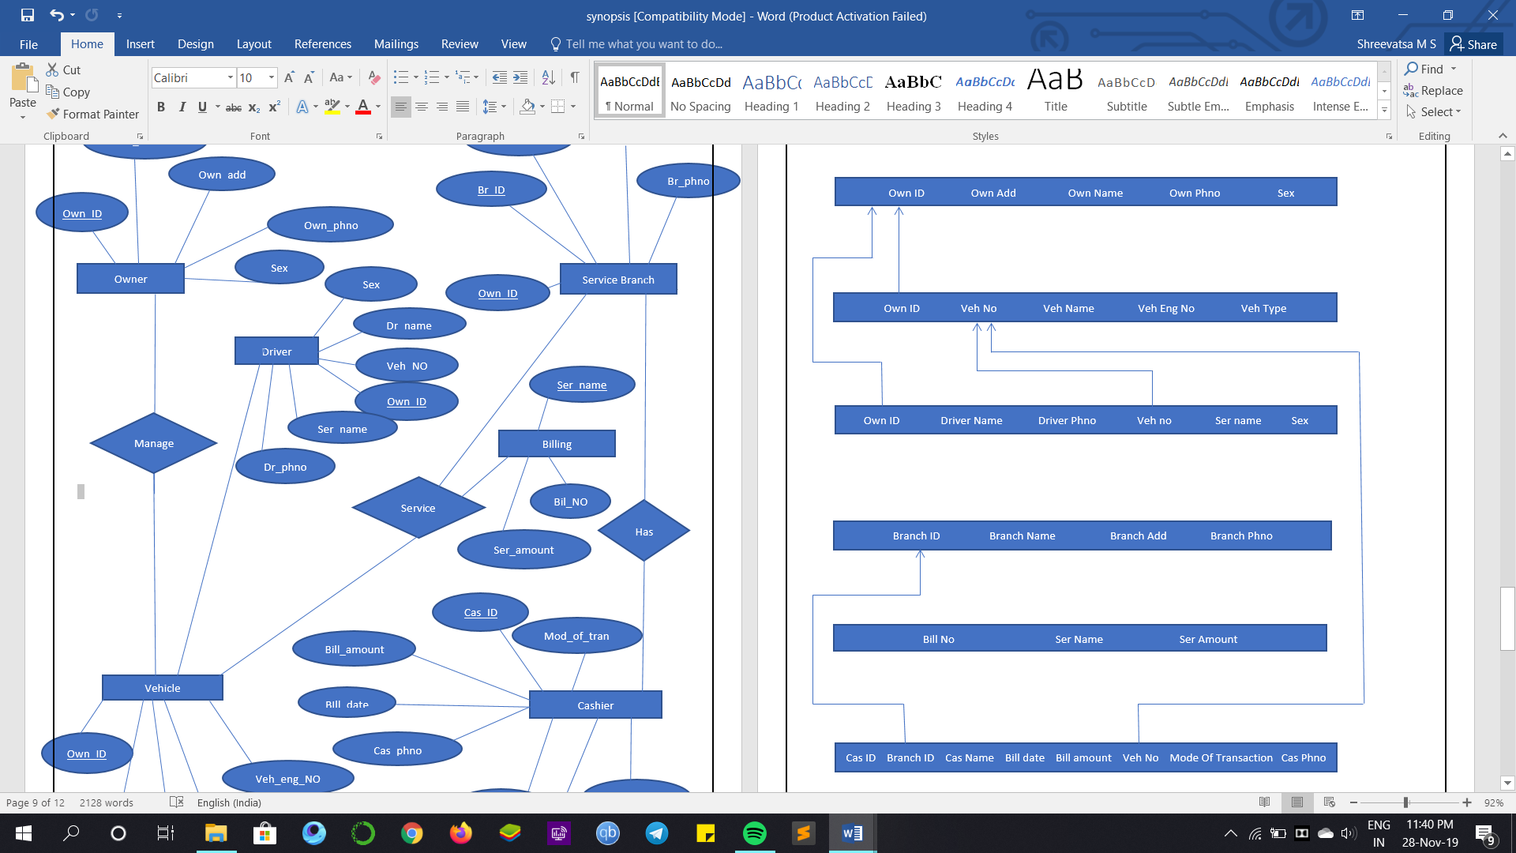

**CHAPTER 4**

**SYSTEM IMPLEMENTATION**

**4.1 IMPLEMENTATION**

Implementation is the stage in the project where the theoretical design is turned into a working system and is giving confidence on the new system for the users that it will work efficiently and effectively. It involves careful planning, investigation of the current system and its constraints on implementation, design of methods to achieve the changeover, an evaluation of change over methods.

According to this plan, the activities are to be carried out, discussions made regarding the equipment and resources and the additional equipment must be acquired to implement the new system. Implementation is the final and most important phase.

**4.1.1 FRONT END**

**PHP:**

PHP is the server-side scripting language designed primarily for web development but also used as a general-purpose programming language.

PHP started out as small open source project that evolved as more and more people found out how useful it was. Ramus Leadoff unleashed the first version of php way back in 1994. PHP is a recursive acronym for “PHP: Hypertext Pre-Processor”. It is used to manage dynamic content, databases, session tracking, even build entire e-commerce sites.

It is integrated with number of popular databases, including MySQL, PostgreSQL, Oracle, Sybase, Informix and Microsoft SQL Server. PHP is pleasingly zippy in its execution, especially when compiled as an apache module on the Unix side. The MySQL server once started executes even very complex queries with huge result sets in record-setting time.

PHP supports a large number of major protocols such as POP3, IMAP and LDAP.PHP4 added support for java and distributes object architectures (COM and CORBA), making n-tier development a possibility for the first time. PHP is forgiving: PHP tries to be as forgiving as possible, PHP syntax is C-like.

**HTML:**

HTML (Hyper Text Markup Language) is the standard markup language for creating pages and web applications. With Cascading Style Sheets (CSS) and JavaScript. Web Browsers receive HTML documents from a web server or local storage and render the documents into multi-media web pages. HTML describes the structure of a web page semantically. HTML elements are the building blocks HTML pages. With HTML constructs, images and other objects such as interactive forms maybe embedded into the rendered page. HTML provides a means to create structured document by denoting structural semantics for text such as headings, paragraphs, lists, links and other items.

**CSS:**

**Cascading Style Sheets** (**CSS**) is a style sheet language used for describing the presentation of a document written in a markup language like HTML. CSS is a cornerstone technology of the World Wide Web, alongside HTML and JavaScript.

CSS is designed to enable the separation of presentation and content, including layout, colors, and fonts. This separation can improve content accessibility, provide more flexibility and control in the specification of presentation characteristics, enable multiple web pages to share formatting by specifying the relevant CSS in a separate .css file, and reduce complexity and repetition in the structural content.

**JavaScript:**

**JavaScript** often abbreviated as **JS**, is a high-level, interpreted scripting language that conforms to the ECMAScript specification. JavaScript has curly-bracket syntax, dynamic typing, prototype-based object-orientation, and first-class functions.

Alongside HTML and CSS, JavaScript is one of the core technologies of the World Wide Web. JavaScript enables interactive web pages and is an essential part of web application. Many websites use it, and major web browsers have a dedicated JavaScript engine to execute it.

Although there are similarities between JavaScript and Java, including language name, syntax, and respective standard libraries, the two languages are distinct and differ greatly in design.

**Bootstrap:**

**Bootstrap** is a free and open-source CSS framework directed at responsive, mobile-first front-end web development. It contains CSS- and (optionally) JavaScript-based design templates for typography, forms, buttons, navigation and other interface components.

**4.1.2 BACKEND**

**MYSQL:**

MYSQL is a open source relational database management system (RDBMS) based on Structured Query Language (SQL). MySQL is written in C and C++. MySQL works on many system platforms, including AIX, FreeBSD, HP-UX, etc. The MySQL server software itself and the client libraries use dual -licensing distribution.

They are offered under GPL version 2 with its proven performance, reliability and ease of use, MySQL has become leading database choice for web-based applications used by high profile web properties including Facebook, twitter etc. Oracle drives MySQL innovation, delivering new capabilities to power next generation web, cloud, mobile and embedded application.

**XAMPP:**

XAMPP is a web development platform that uses windows as the operating system , apache as the web server , MYSQL as the relational database management system and PHP as the object oriented scripting language.

It is a free and open source cross platform web server solution stack package developed by Apache Friends, consisting mainly of the Apache HTTP server, Maria DB database, and interpreters for scripts written in PHP and Perl programming languages. Since most actual web server deployments used the same components as XAMPP, it makes transitioning from a local test server to a live server possible.

XAMPPs ease of development means a WAMP or LAMP Stack can be installed quickly and simply on an operating system by a developer, with the advantage a number of common add-in applications such as WordPress and Joomla can also be installed with similar ease using Bitnami.

* 1. **MODULES**
* **Administrator**
* **Customer**

**Module Description:**

**Administrator**

Admin module contains booking form, display form, delete form, update form, services form, feedback form, logs form which are registered from the customers.

[1] Display

[2]Update

[3]Delete

[4]Services

[5]Feedback

**Customer**

This module deals with the details about the customers who are eager to do services in the service centre.

The following are the forms that exist in this module

* Registration form
* Bill Generation
* Login Form
* Status form
* Feedback Form

**IMPLEMENTATION CODE:**

<!DOCTYPE html>

<html lang="en">

<head>

<title>Slim - Free Bootstrap 4 Template by Colorlib</title>

<meta charset="utf-8">

<meta name="viewport" content="width=device-width, initial-scale=1, shrink-to-fit=no">

<link href="https://fonts.googleapis.com/css?family=Nunito+Sans:200,300,400,600,700,800,900" rel="stylesheet">

<link rel="stylesheet" href="css/open-iconic-bootstrap.min.css">

<link rel="stylesheet" href="css/animate.css">

<link rel="stylesheet" href="css/owl.carousel.min.css">

<link rel="stylesheet" href="css/owl.theme.default.min.css">

<link rel="stylesheet" href="css/magnific-popup.css">

<link rel="stylesheet" href="css/aos.css">

<link rel="stylesheet" href="css/ionicons.min.css">

<link rel="stylesheet" href="css/flaticon.css">

<link rel="stylesheet" href="css/icomoon.css">

<link rel="stylesheet" href="css/style.css">

</head>

<body data-spy="scroll" data-target=".site-navbar-target" data-offset="300">

<nav class="navbar navbar-expand-lg navbar-dark ftco_navbar bg-dark ftco-navbar-light site-navbar-target" id="ftco-navbar">

<div class="container">

<a class="navbar-brand" href="index.html">Automobile Service</a>

<button class="navbar-toggler js-fh5co-nav-toggle fh5co-nav-toggle" type="button" data-toggle="collapse" data-target="#ftco-nav" aria-controls="ftco-nav" aria-expanded="false" aria-label="Toggle navigation">

<span class="oi oi-menu"></span> Menu

</button>

<div class="collapse navbar-collapse" id="ftco-nav">

<ul class="navbar-nav nav ml-auto">

<li class="nav-item"><a href="#home-section" class="nav-link"><span>HOME</span></a></li><li class="nav-item"><a href="#customer-section" class="nav-link"><span>Customer</span></a></li><li class="nav-item"><a href="#programs-section" class="nav-link"><span>Programs</span></a></li> <li class="nav-item"><a href="#schedule-section" class="nav-link"><span>Schedule</span></a></li><liclass="nav-item"><ahref="#about-section" class="nav-link"><span>About</span></a></li>

<liclass="nav-item"><ahref="#contact-section"class="nav-link"><span>Contact</span></a></li>

<li class="nav-item"><a href="#admin-section" class="nav-link"><span>ADMIN PANEL</span></a></li>

</ul>

</div>

</div>

</nav>

</body>

</html>

<?php

$conn = mysqli_connect("localhost","root","","feedback");

if($conn->connect_error) {

die("connection failed:". $conn-> connect_error);

}

$sql="select name,email,rating,comment from feedback";

$result=$conn->query($sql);

if($result->num_rows >0){

while ($row=$result-> fetch_assoc()){

echo"<tr><td>".$row["name"] ."</td><td>" .$row["email"] ."</td><td>" .$row["rating"] ."</td><td>" .$row["comment"] ."</td><td>";

}

echo"</table>";

}

else {

echo "0 result";

}

$conn->close();

?>

**CHAPTER 6**

**TESTING**

**6.1 SOFTWARE TESTING**

**Software Testing Strategies**

Testing is a set of activities that can be planned in advanced and conducted systematically. A strategy for software testing must accommodation low-level tests that are necessary to verify that a small source code segment has been correctly implemented as well as high-level tests that validate major system functions against customer requirements

There are three types of testing strategies

1. Unit test

2. Integration test

**Unit Testing:**

Unit testing focuses verification efforts on the smallest unit of software design module. The unit test is always white box oriented. The tests that occur as part of unit testing are testing the module interface, examining the local data structures, testing the boundary conditions, execution all the independent paths and testing error-handling paths.

|  |  |  |  |  |  |
| --- | --- | --- | --- | --- | --- |
| S/No. of Test Case | Features being Tested | Description | Expected Output | Actual Out- put | Remarks |
| 1 | Insertion Test | Insert a new record | The record is inserted into  file | The record is successfully  inserted | Pass |
| 2 | Insertion Test | Insert a new record | The record is inserted into file | The record is not success- fully inserted | Fail |

**Integration Testing:**

Integration testing is a systematic technique or construction the program structure while at the same time conducting tests to uncover errors associated with interfacing. Scope of testing summarizes the specific functional, performance, and internal design characteristics that are to be tested. It employs top-down testing and bottom-up testing methods for this case.

|  |  |  |  |  |  |
| --- | --- | --- | --- | --- | --- |
| S/No. of Test  Case | Features being Tested | Description | Expected  Output | Actual Output | Remarks |
| 1 | Insertion | Adding data to the file | Prompt message | Prompt message | Success |
| 2 | Modify | Modify data in the record | Prompt message | Prompt message | Success |
| 3 | Display | Displays  records | Displays records | Displays records | Success |
| 4 | Delete | Accepting deletion  prompt | Element is deleted | Element is deleted | Success |

**TESTCASES:**

**Test Case 1:** Inserting record

|  |  |
| --- | --- |
| S/No. | 1 |
| Feature being tested | Inserting |
| Description | Adding data to file |
| Expected output | Prompt message appears to add data to the file |
| Actual output | Prompt message appears to add data to the file |
| Remarks | Pass |

**Test Case 2:** Deleting record

|  |  |
| --- | --- |
| S/No. | 2 |
| Feature being tested | Delete |
| Description | Deleting record from file |
| Expected output | Record deleted |
| Actual output | Record deleted |
| Remarks | Pass |

**Test Case 6:** Displaying record

|  |  |
| --- | --- |
| S/No. | 3 |
| Feature being tested | Display |
| Description | Displaying records in file |
| Expected output | Record found and displayed |
| Actual output | Record found and displayed |
| Remarks | Pass |

**CHAPTER 7**

**SNAPSHOTS**

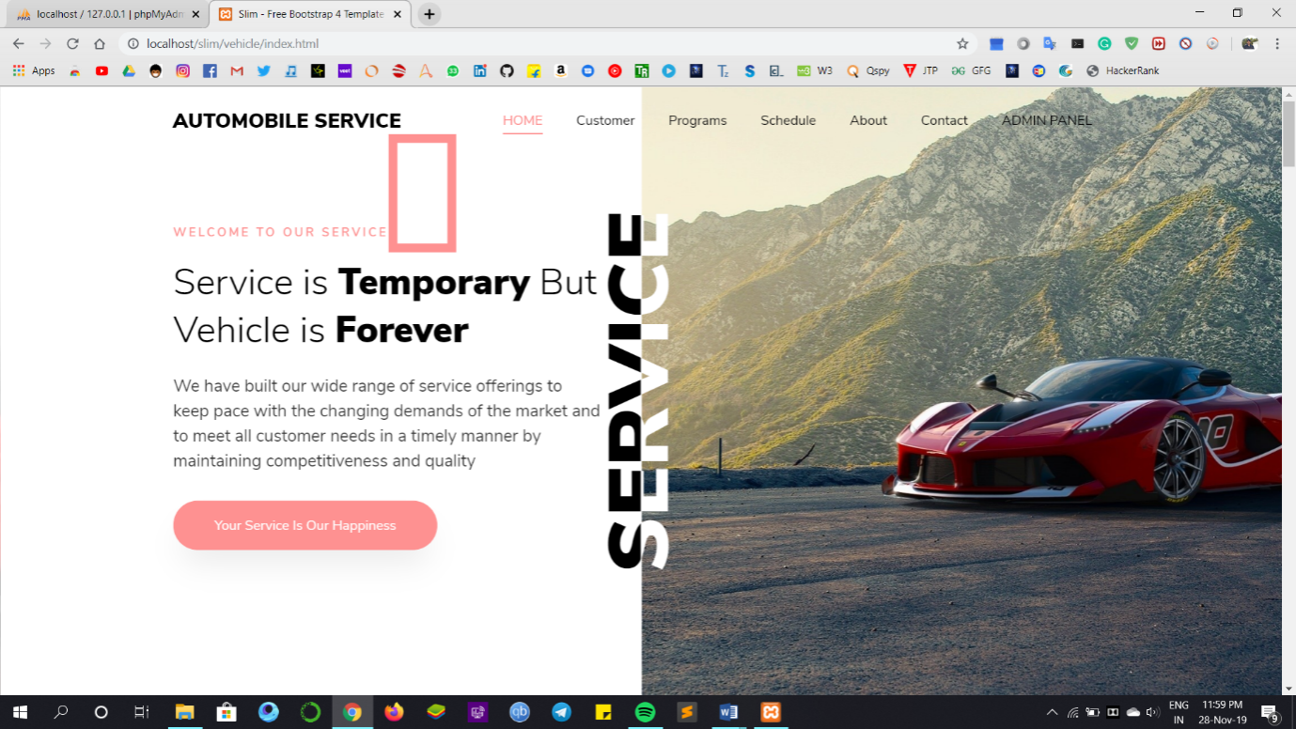

Fig 7.1: Home Page

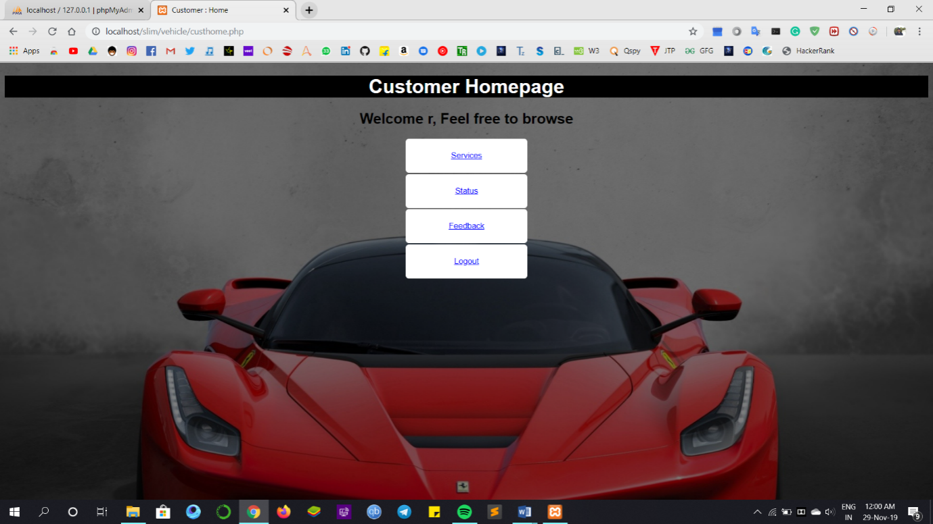Fig 7.2: Customer Home Page

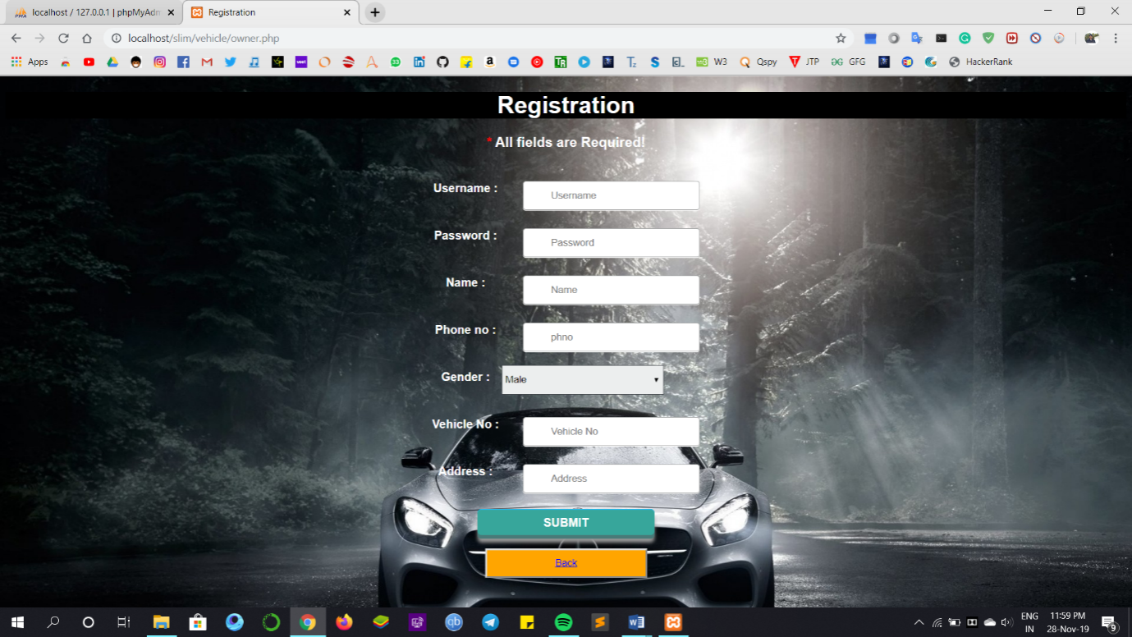

Fig 7.3:Registration

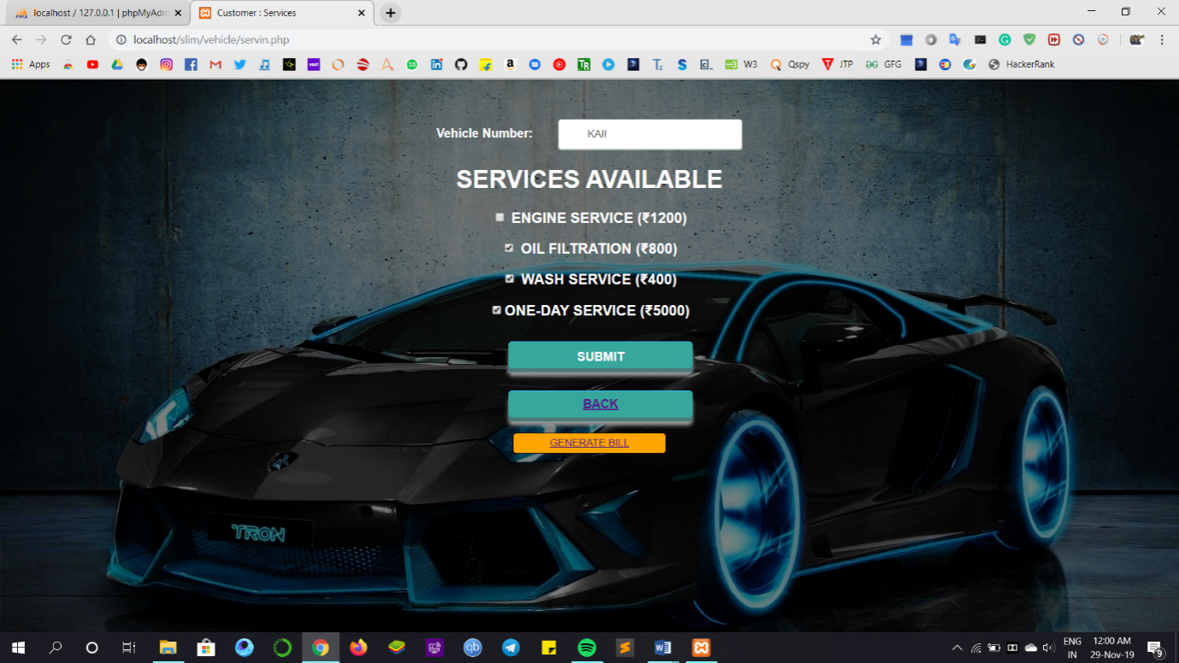

Fig 7.4:Services

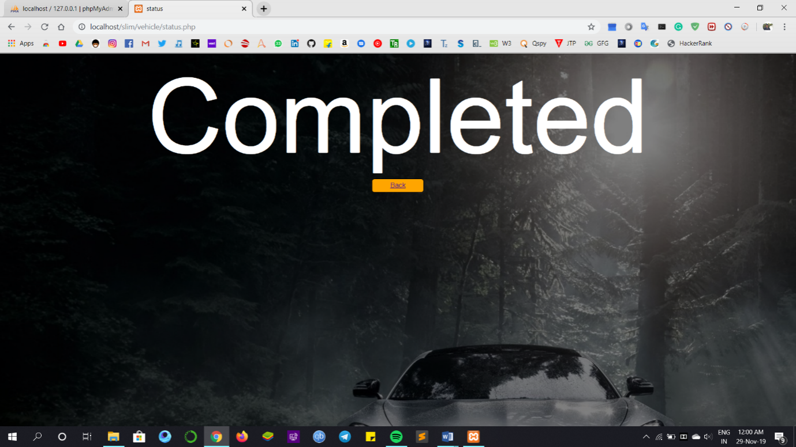

Fig 7.5:Service Status

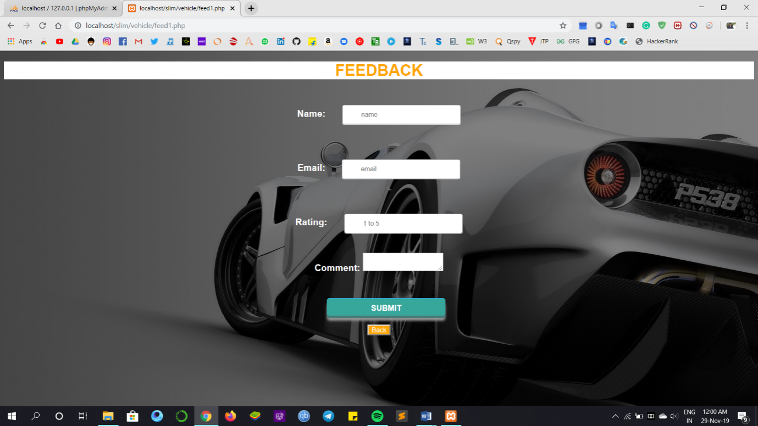

Fig 7.6:Feedback

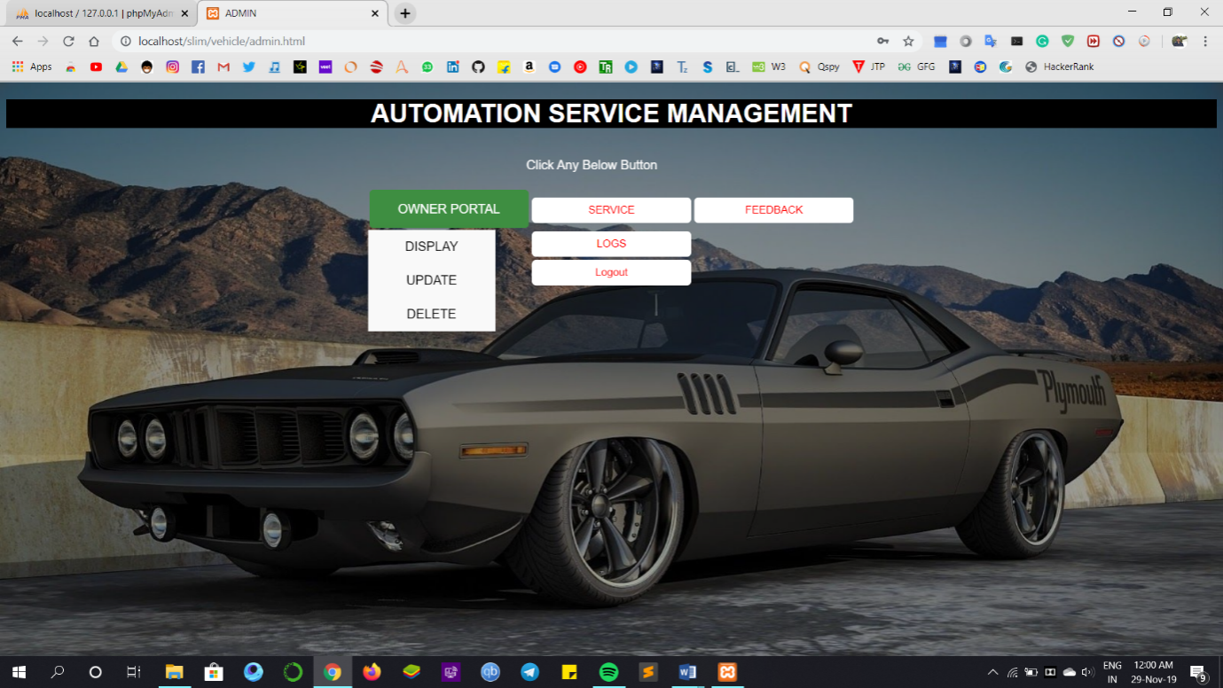

Fig 7.7: Admin Panel

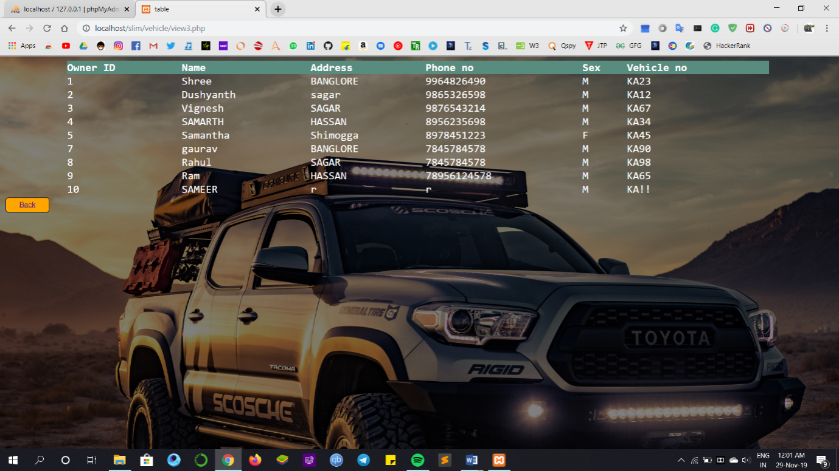

Fig 7.8:Display Customers

**CHAPTER 8**

**CONCLUSION**

The entire project has been developed and deployed as per the requirements stated by the user, it is found to be bug free as per the testing standards that is implemented. Any specification-untraced errors will be concentrated in the coming versions, which are planned to be developed in near future. The system at present does not take care off the money payment methods, as the consolidated constructs need SSL standards and are critically to be initiated in the first face; the application of the credit card transactions is applied as a developmental phase in the coming days. The system needs more elaborative technicality for its inception and evolution.

**REFERENCES**

[1] Randy Connolly, Ricardo Hoar, "Fundamentals of Web Development”, 1st Edition, Pearson Education India.

[2] Robin Nixon, “Learning PHP, MySQL &JavaScript with jQuery, CSS and HTML5”, 4th Edition, O’Reilly Publications, 2015.

[3] Nicholas C Zakas, “Professional JavaScript for Web Developers”, 3rd Edition, Wrox/Wiley India, 2012.

[4] David Sawyer Mcfarland, “JavaScript & jQuery: The Missing Manual”, 1st Edition, O’Reilly/Shroff Publishers & Distributors Pvt Ltd, 2014.

[5] Websites:

* [www.w3schools.com](http://www.w3schools.com/)
* [www.scribd.com](http://www.scribd.com/)
* [www.wikipedia.org](http://www.wikipedia.org/)